AI ASSIGNMENT-11.1
NAME:PENNA BHARGAVI
BATCH:44
2303A52391
Task Description #1 – Stack Implementation
Task: Use AI to generate a Stack class with push, pop, peek, and is_empty
methods.
Sample Input Code:
class Stack:
pass
Expected Output:
• A functional stack implementation with all required methods and
Docstrings

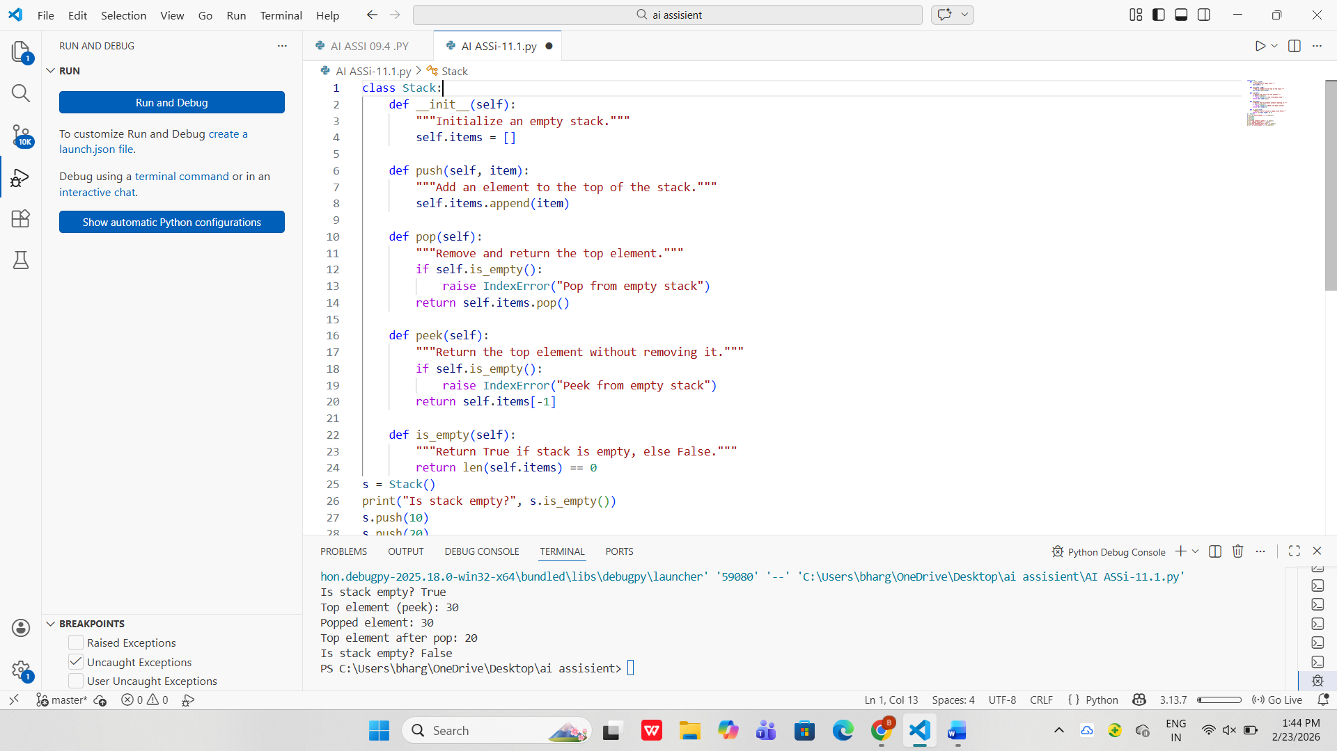
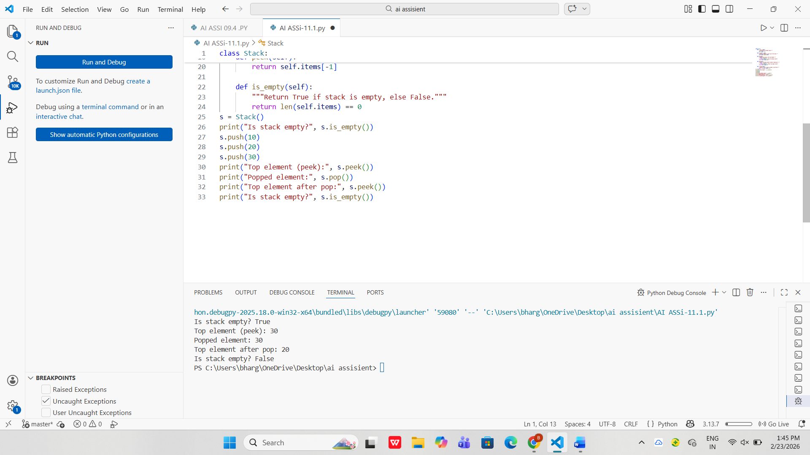

Task Description #2 – Queue Implementation
Task: Use AI to implement a Queue using Python lists.
Sample Input Code:
class Queue:
pass
Expected Output:
• FIFO-based queue class with enqueue, dequeue, peek, and size
methods.
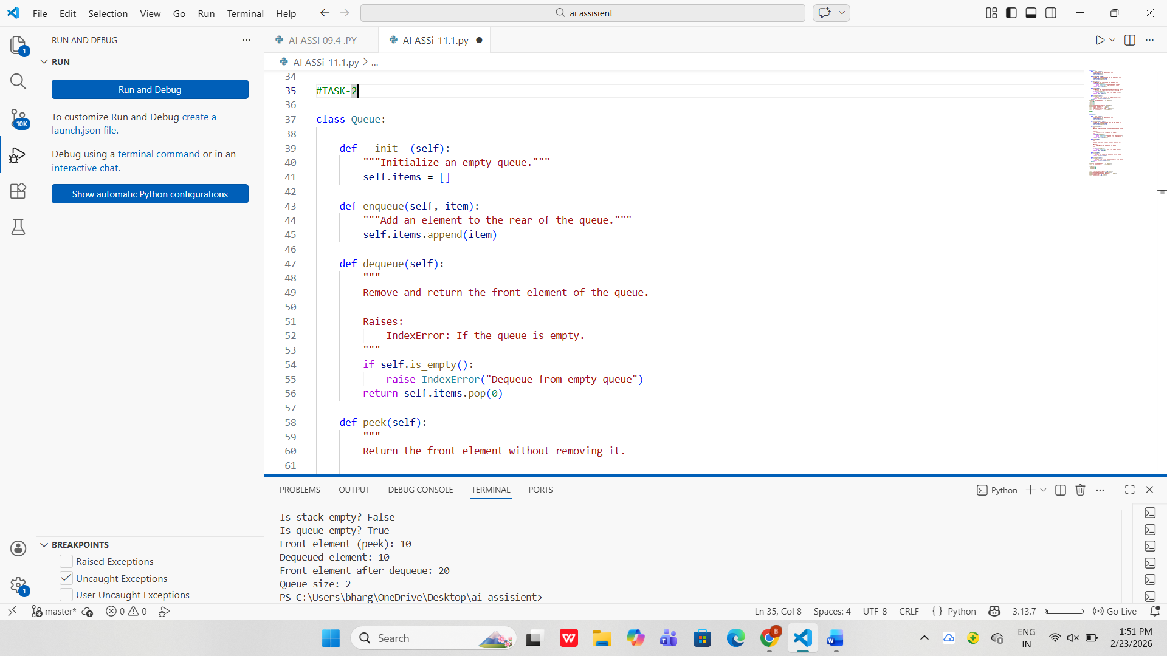

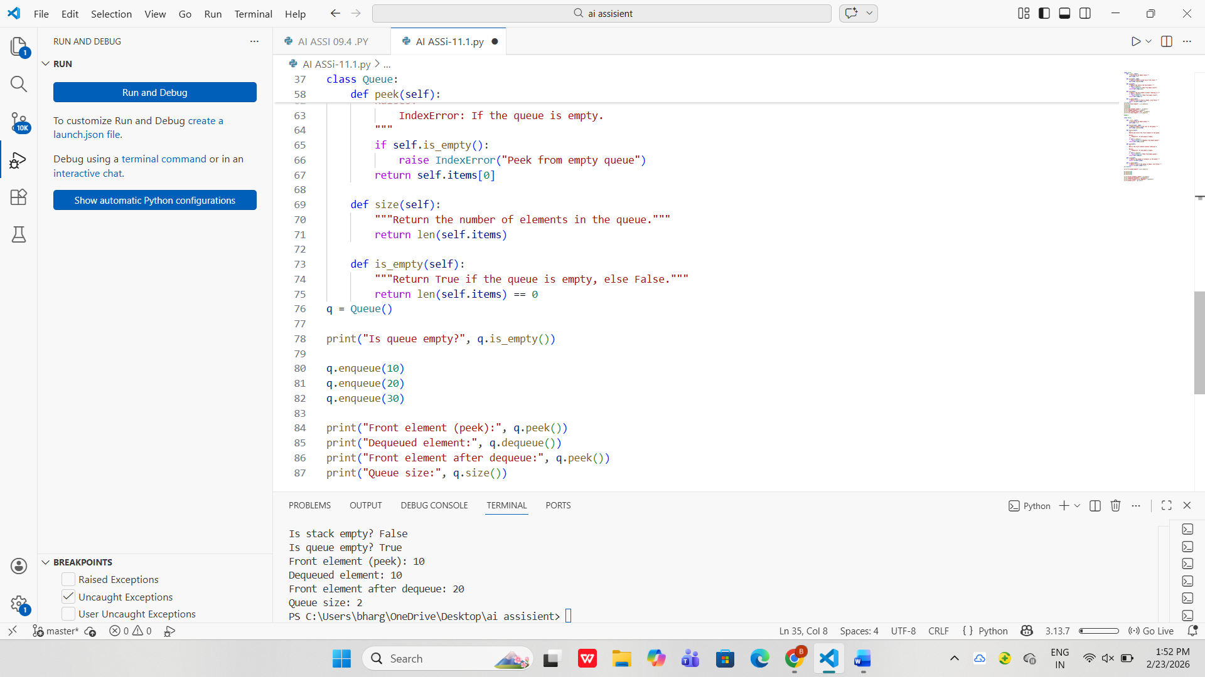

Task Description #3 – Linked List
Task: Use AI to generate a Singly Linked List with insert and display
methods.
Sample Input Code:
class Node:
pass
class LinkedList:
pass
Expected Output:
• A working linked list implementation with clear method
documentation.

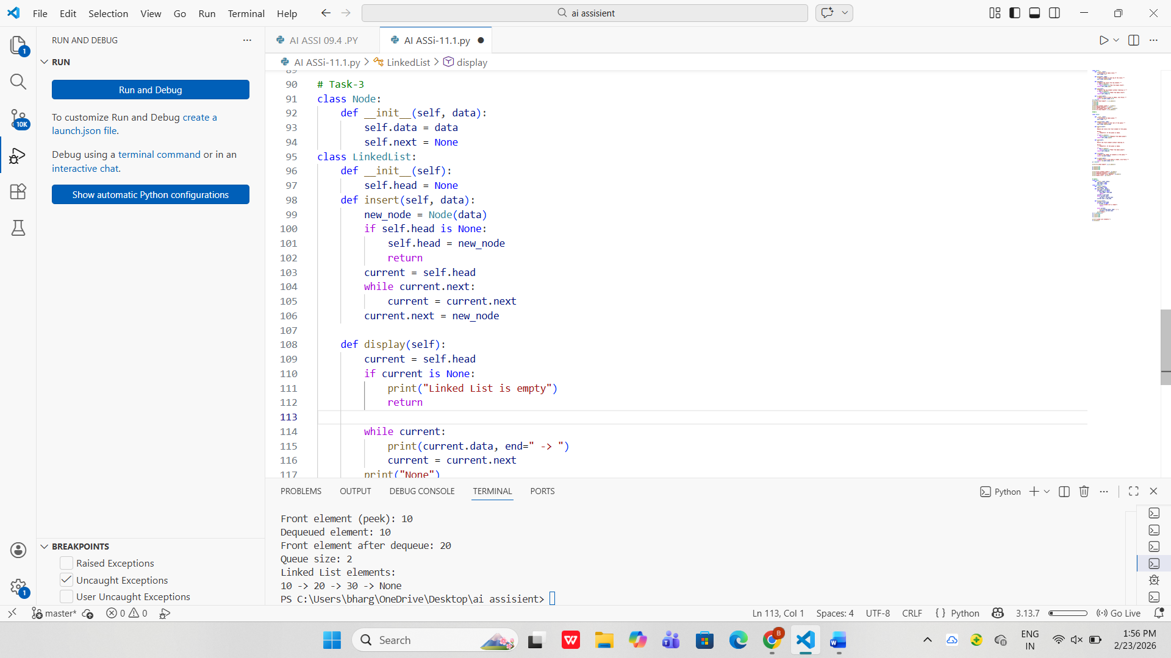

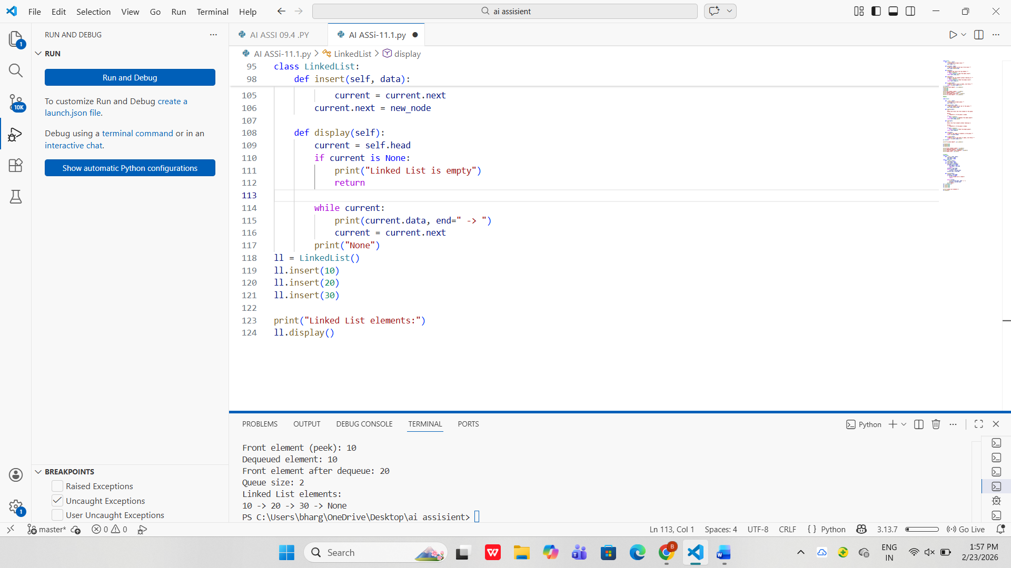

Task Description #4 – Binary Search Tree (BST)
Task: Use AI to create a BST with insert and in-order traversal methods.
Sample Input Code:
class BST:
pass
Expected Output:
• BST implementation with recursive insert and traversal methods.

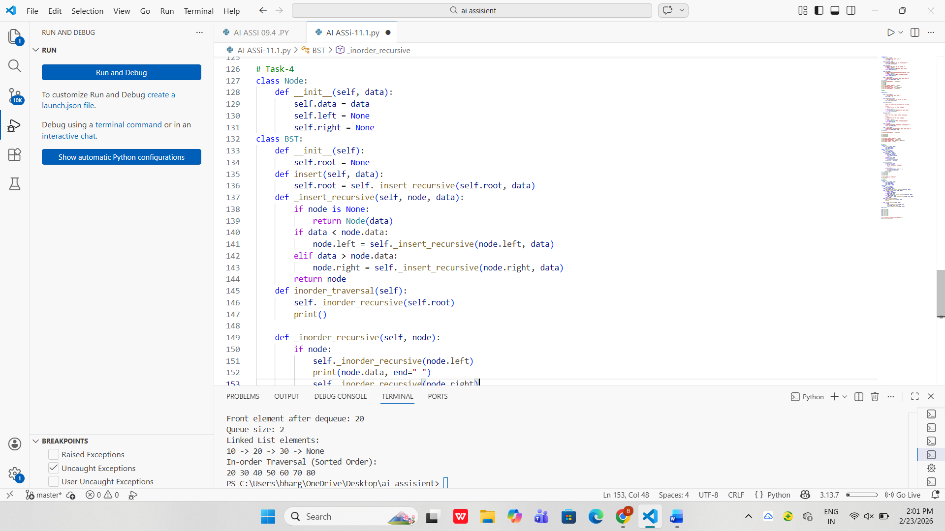

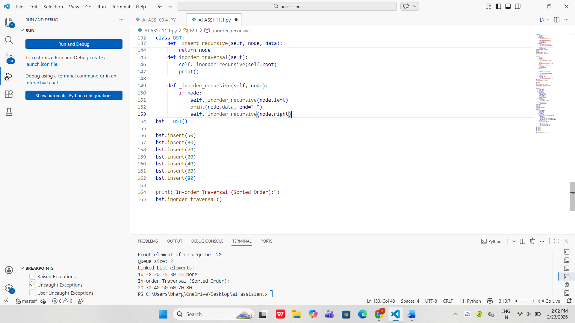

Task Description #5 – Hash Table
Task: Use AI to implement a hash table with basic insert, search, and
delete methods.
Sample Input Code:
class HashTable:
pass
Expected Output:
• Collision handling using chaining, with well-commented methods.

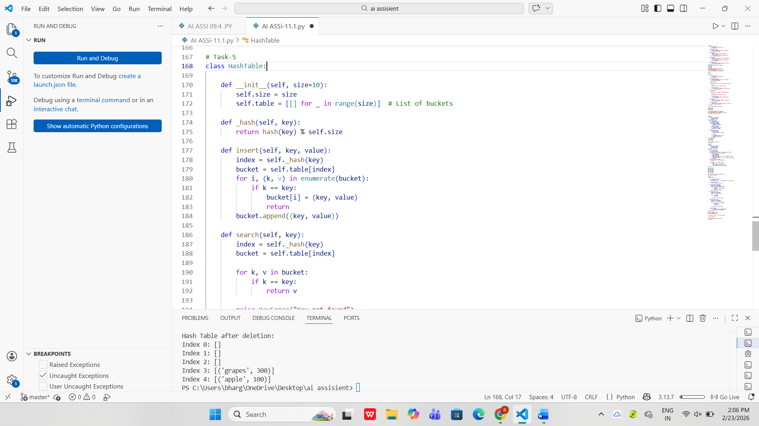

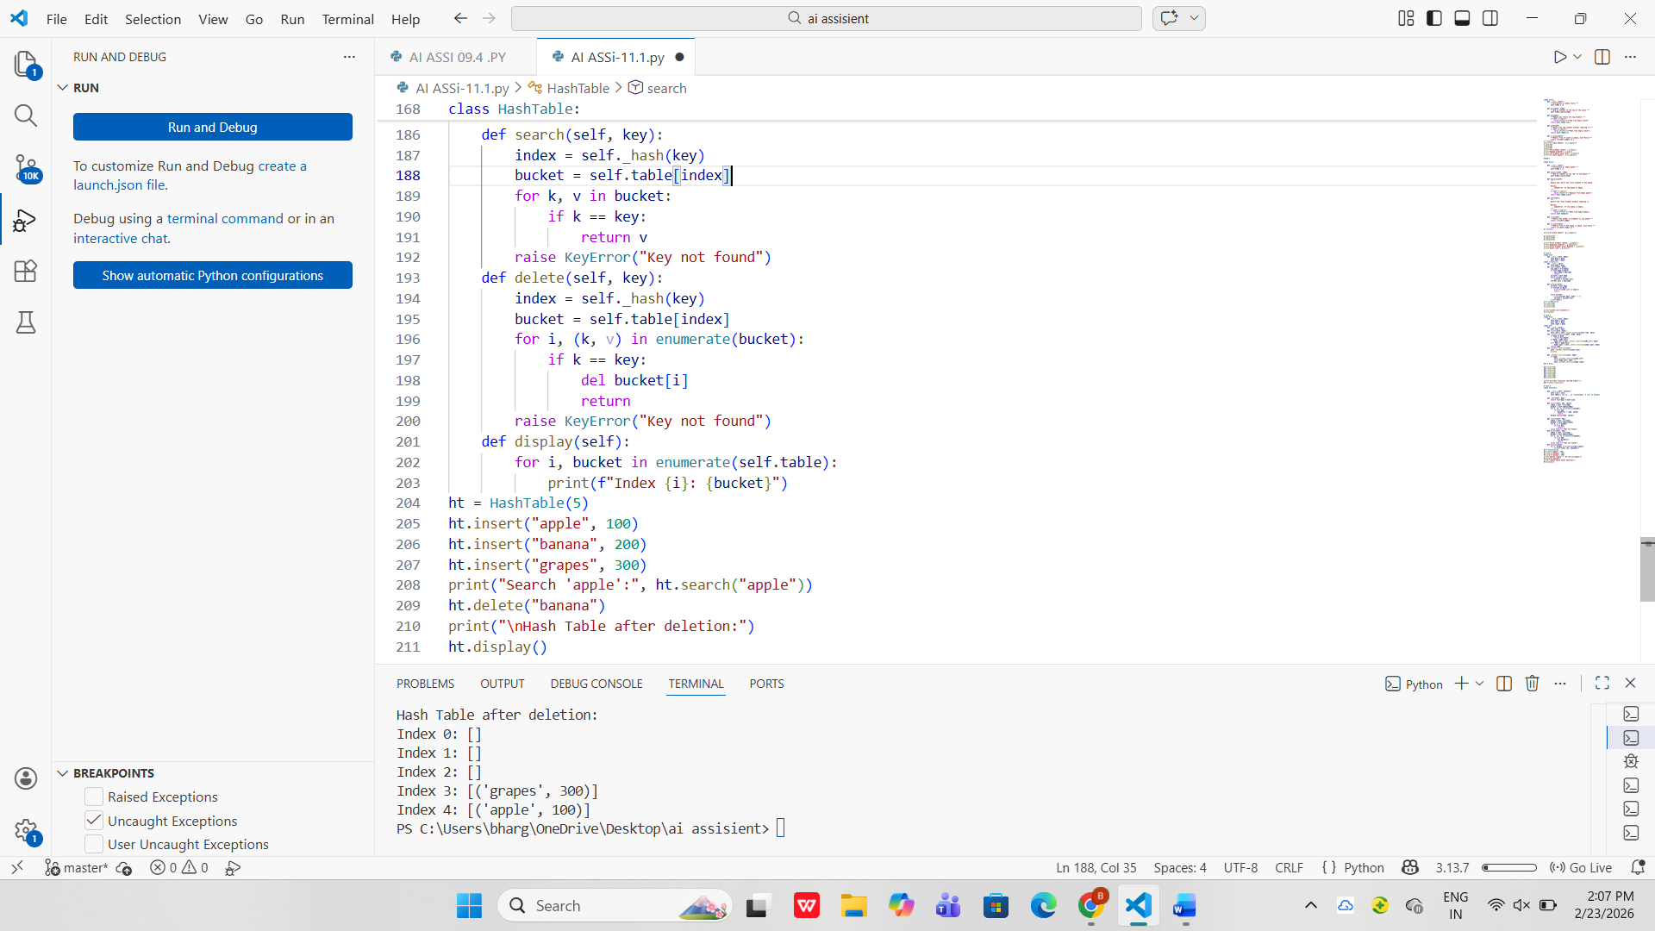

Task Description #6 – Graph Representation
Task: Use AI to implement a graph using an adjacency list.
Sample Input Code:
class Graph:
pass
Expected Output:
• Graph with methods to add vertices, add edges, and display
connections

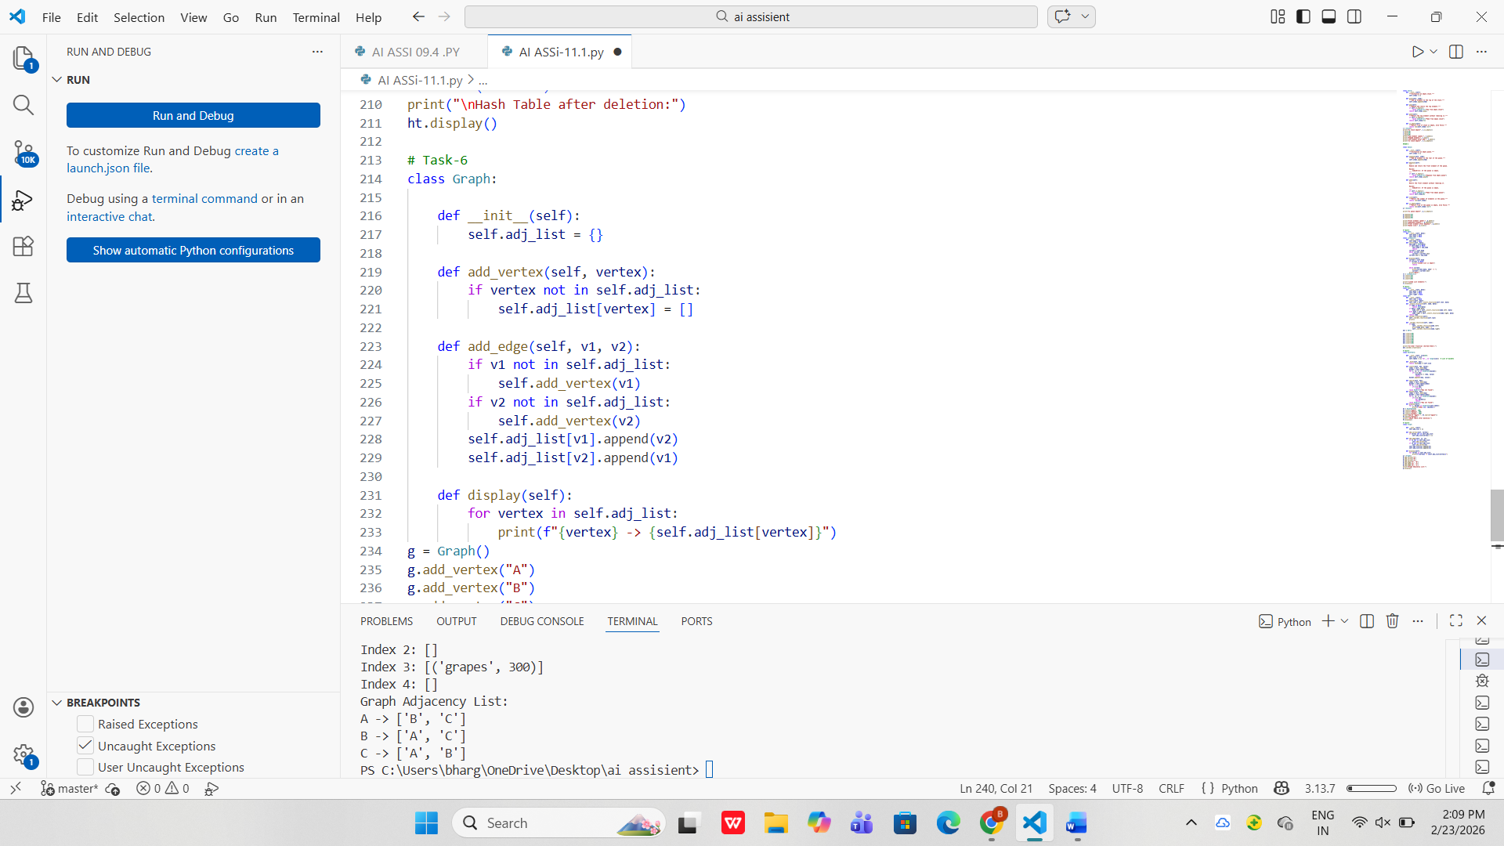

Task Description #7 – Priority Queue
Task: Use AI to implement a priority queue using Python’s heapq
module.
Sample Input Code:
class PriorityQueue:
pass
Expected Output:
• Implementation with enqueue (priority), dequeue (highest priority),
and display methods.

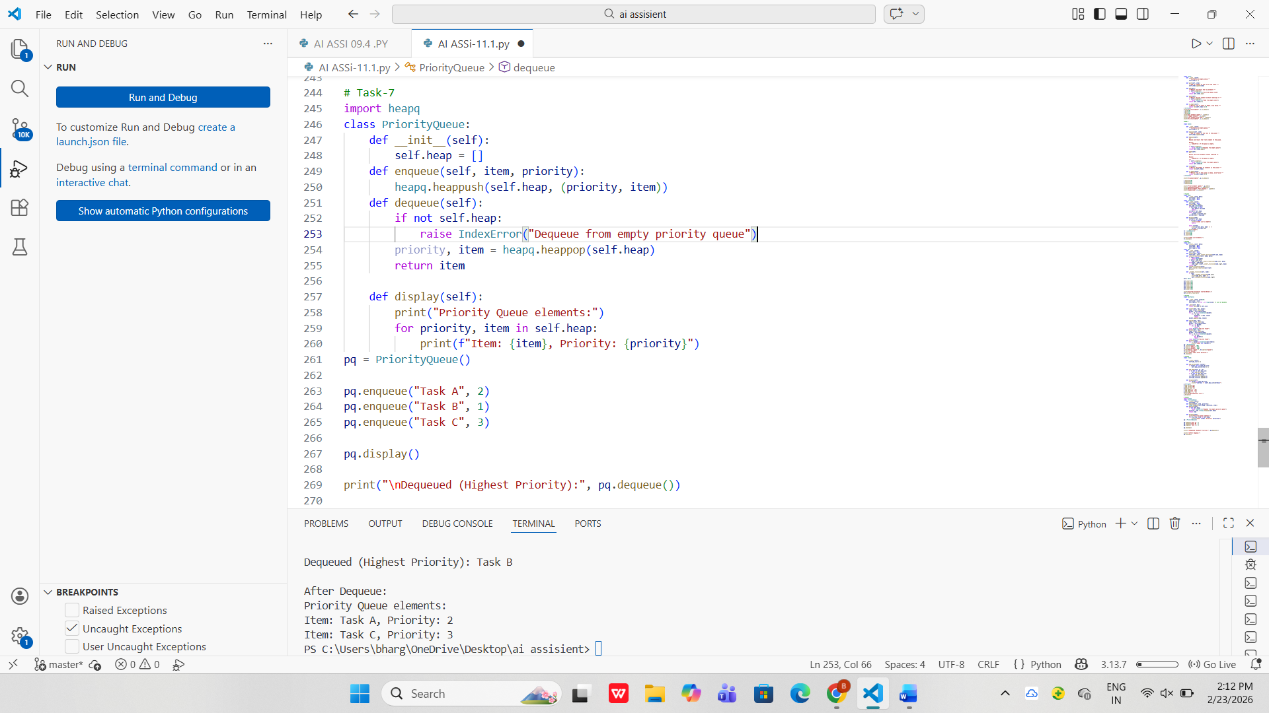

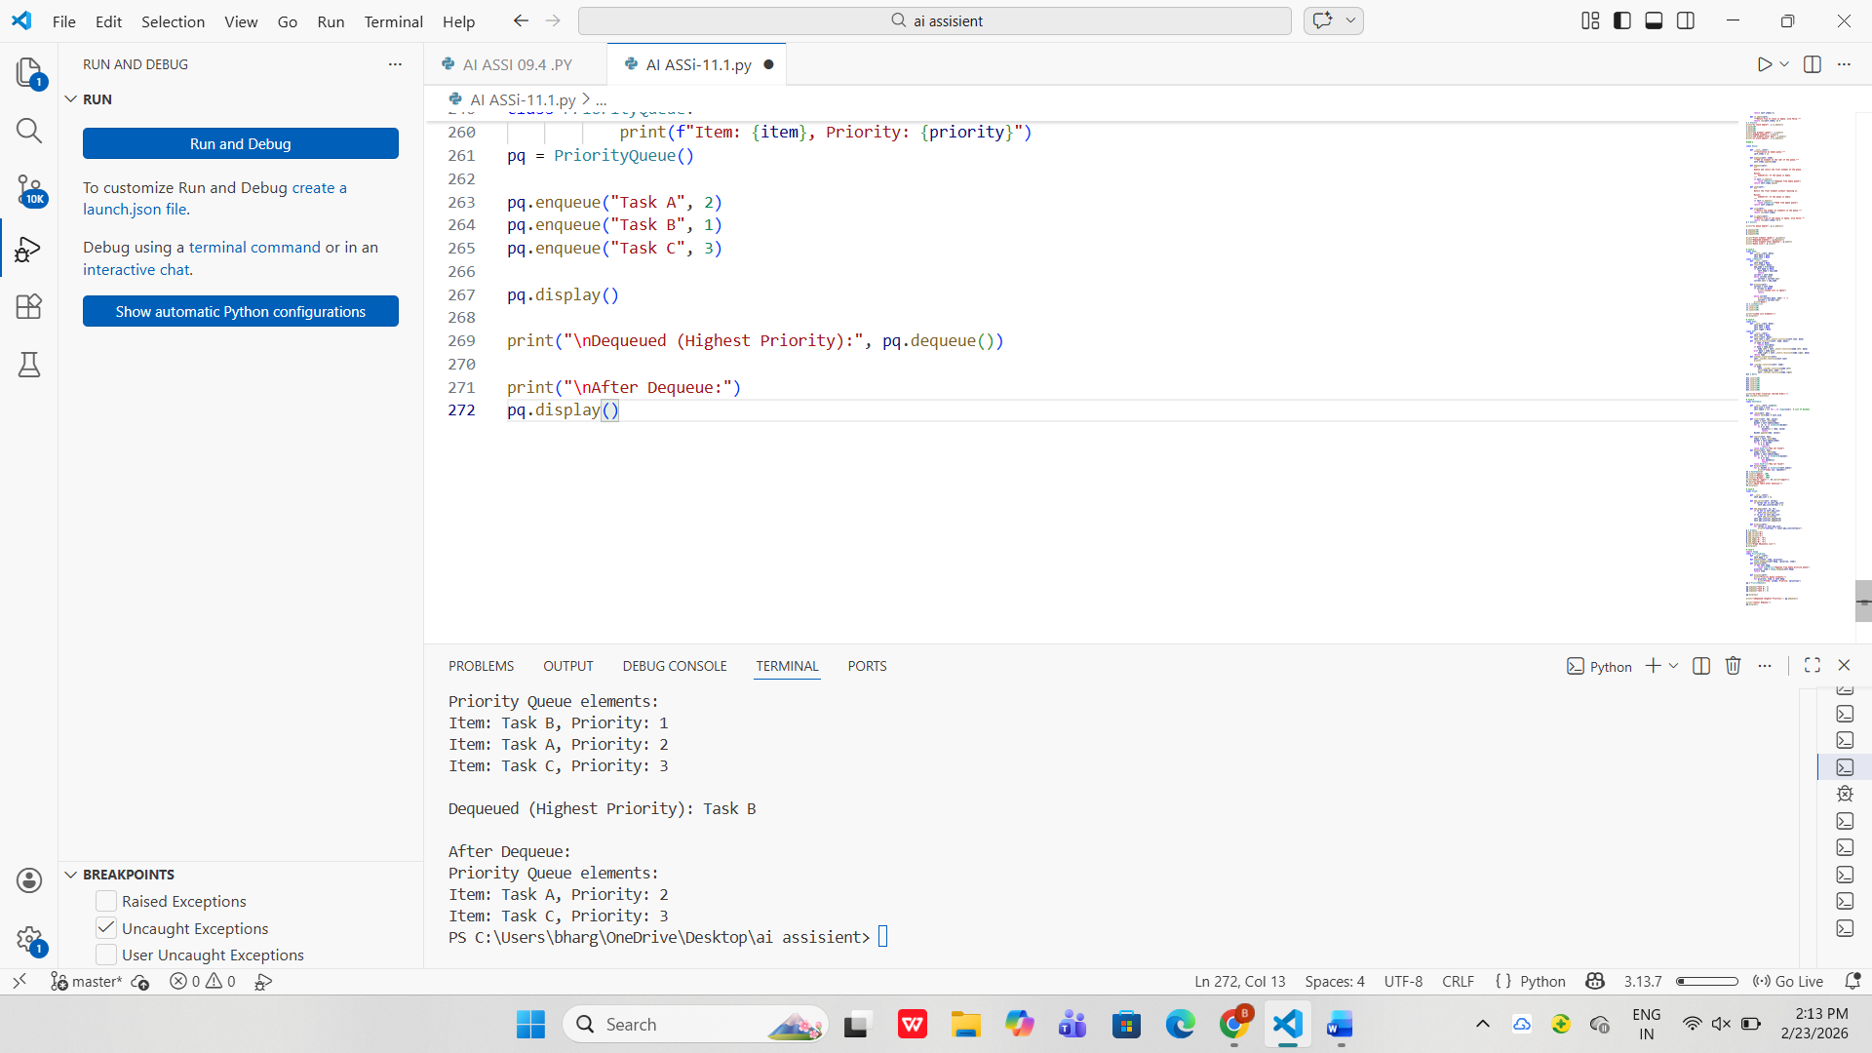

Task Description #8 – Deque
Task: Use AI to implement a double-ended queue using
collections.deque.
Sample Input Code:
class DequeDS:
pass
Expected Output:
• Insert and remove from both ends with docstrings.

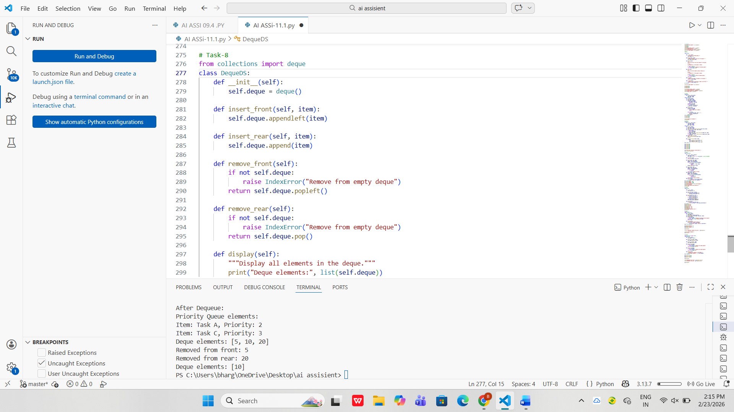

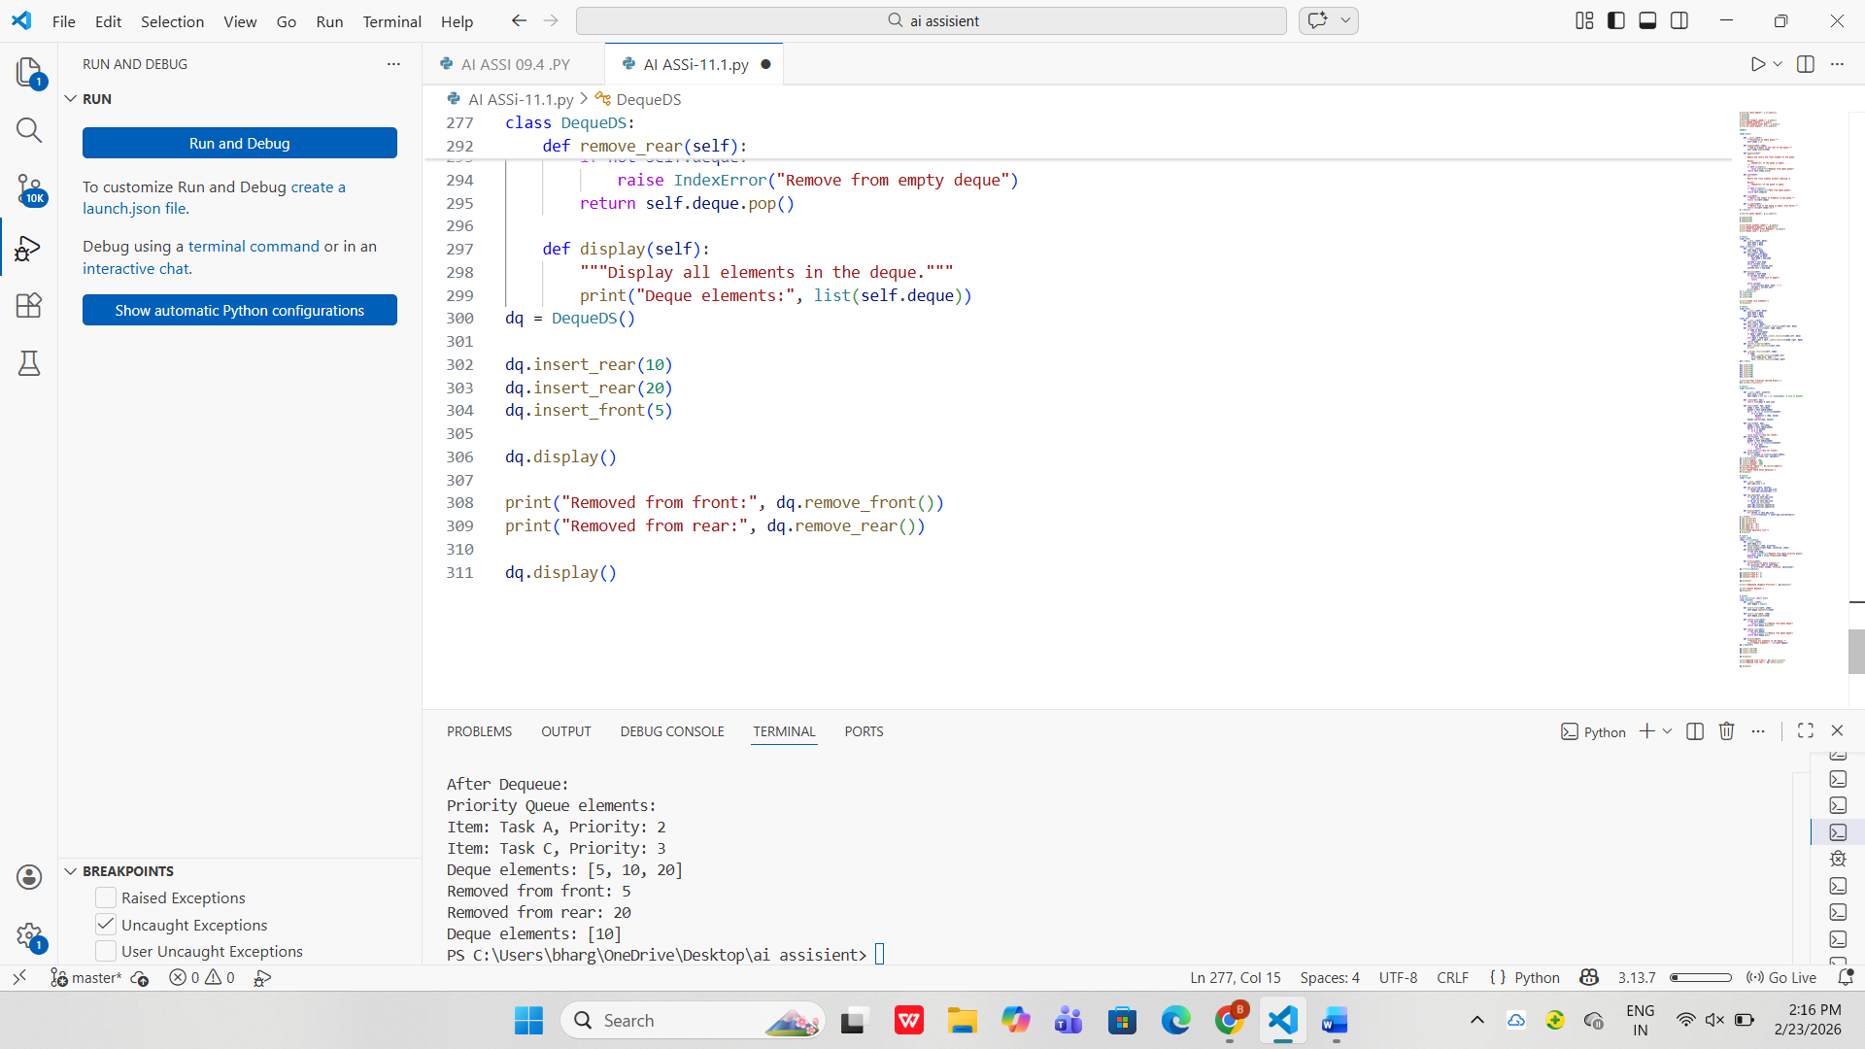

Task Description #9 Real-Time Application Challenge – Choose theRight Data Structure

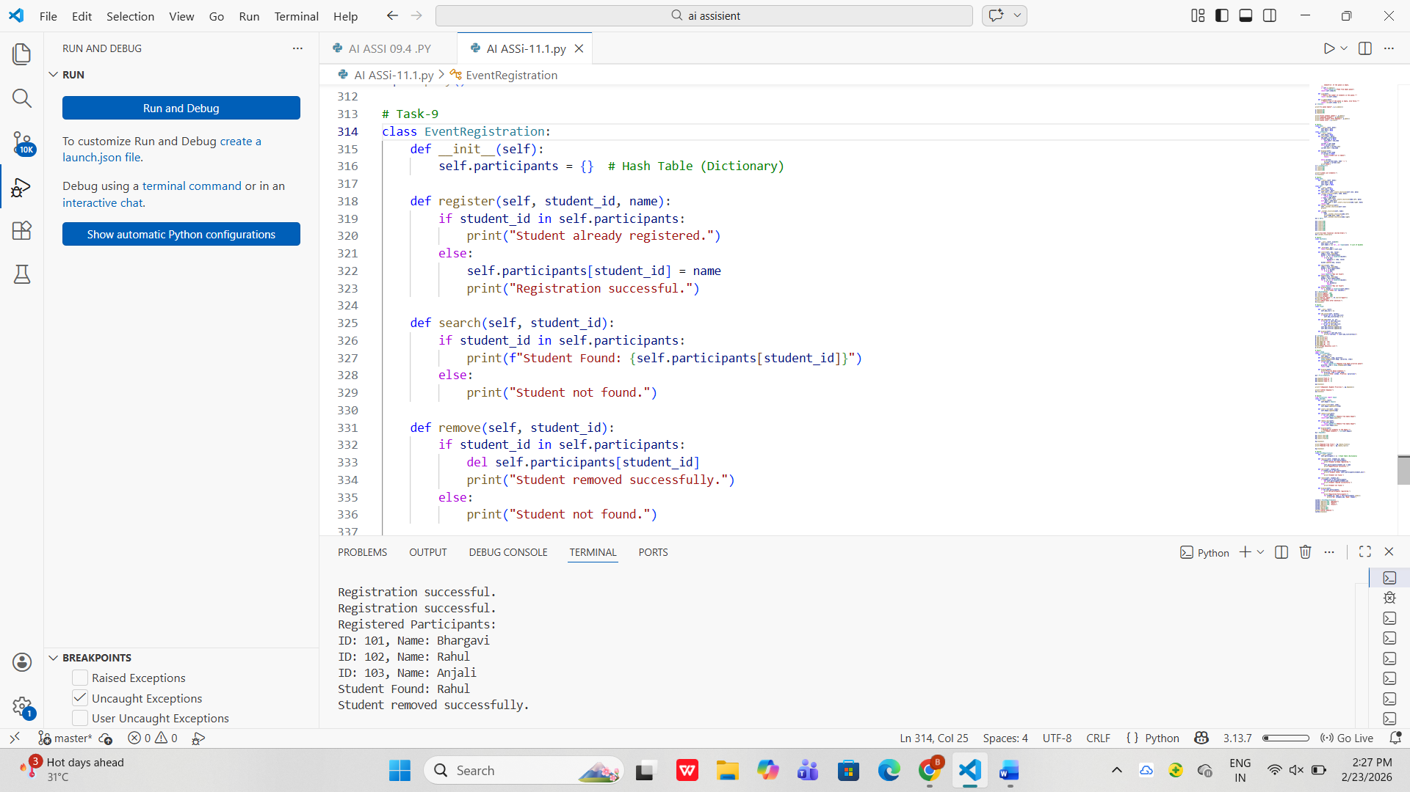
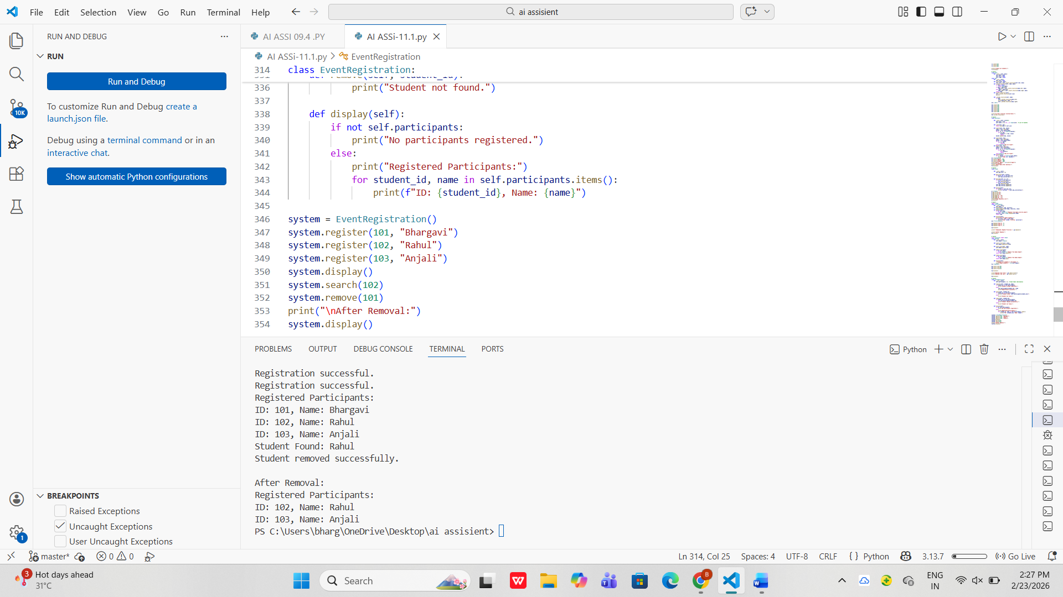

Task Description #10: Smart E-Commerce Platform – Data Structure
Challenge

